- - Carga Datos Tabla Perro

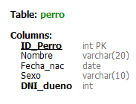

insert into Perro values(10,'Camilo','2020-12-12', 'Macho',10362995)

insert into Perro values(11,'Frida','2021-02-10', 'Hembra',17567123)

insert into Perro values(12,'Lennon','2018-09-07', 'Macho',19533153)

insert into Perro values(13,'Olivia','2019-10-25', 'Hembra',21533122)

insert into Perro values(14,Toto,'2020-02-23', 'Macho',23546987)

insert into Perro values(15,'Fido','2021-02-15', 'Macho',28957346)

insert into Perro values(16,'Puppy','2018-01-01', 'Hembra',31391722)

select \* from Perro

